**11 november os commands**

**QUES 1: PROGRAM TO PRINT N NATURAL NUMBERS.**

**#!/bin/sh**

**echo "Enter n:"**

**read n**

**i=1**

**while [ $i -le $n ]**

**do**

**echo "$i"**

**i=`echo "$i+1"|bc`**

**done**

**output:**

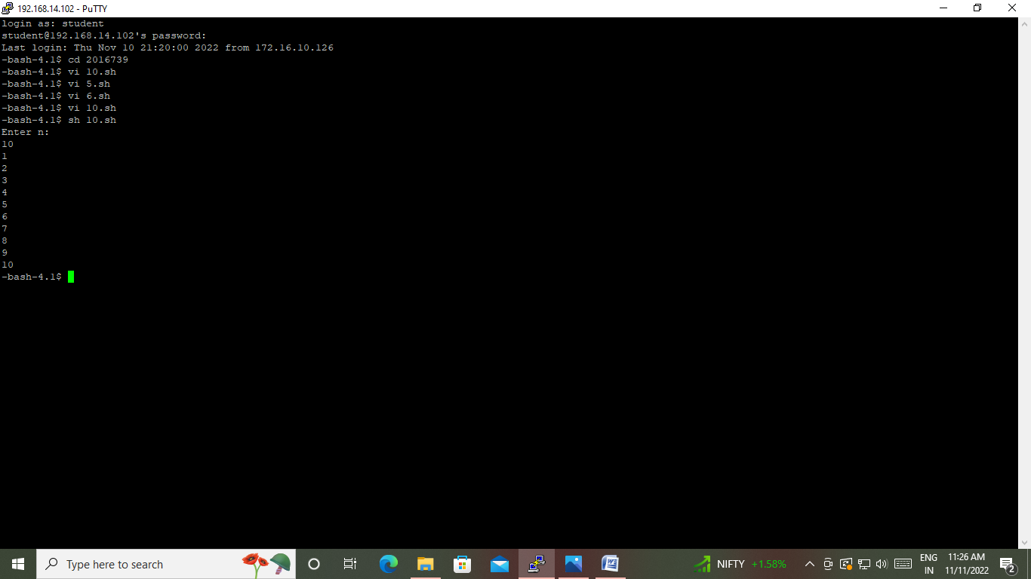

**QUES 2:Print reverse of n natural numbers.**

**#!/bin/sh**

**echo "Enter any number"**

**read n**

**n1=$n**

**rev=0**

**while [ $n -gt 0 ]**

**do**

**r=`echo "$n%10"|bc`**

**rev=`echo "$rev*10+$r"|bc`**

**n=`echo "$n/10"|bc`**

**done**

**echo "Reverse of $n is $rev"**

**OUTPUT:**

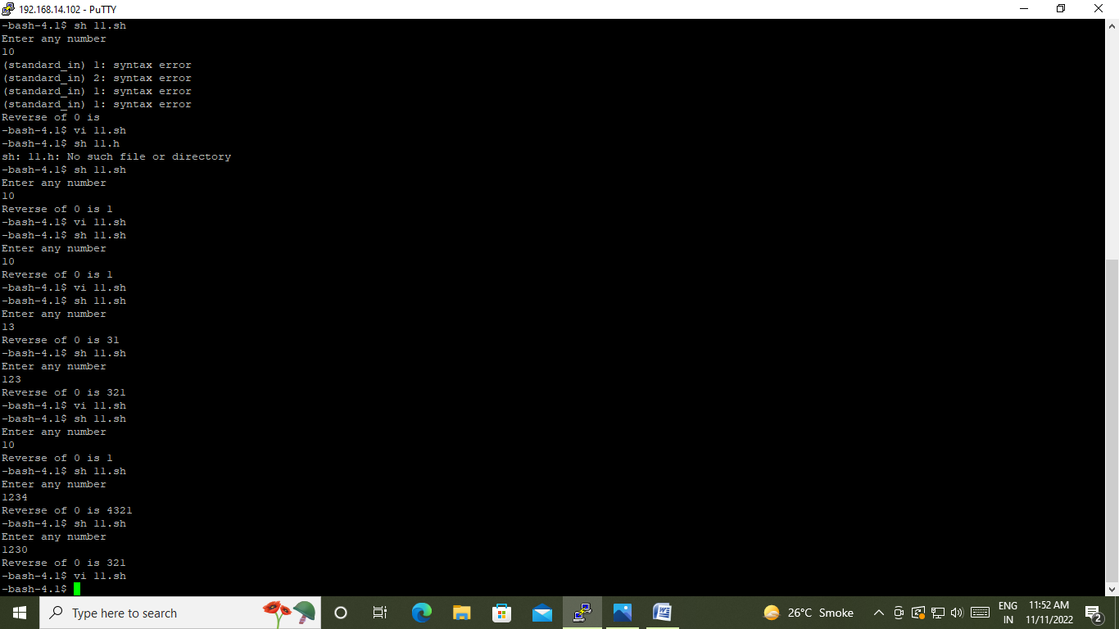

**QUES 3: PROGRAM TO CHECK WHETHER A NUMBER IS PALINDROME OR NOT.**

**#!/bin/sh**

**echo "Enter any Number"**

**read n**

**n1=$n**

**rev=0**

**while [ $n -gt 0 ]**

**do**

**r=`echo "$n%10"|bc`**

**rev=`echo "$rev*10+$r"|bc`**

**n=`echo "$n/10"|bc`**

**done**

**echo "Reverse of $n1 is $rev"**

**if [ $n1 -eq $rev ]**

**then**

**echo "Number is Palindrome"**

**else**

**echo "Number is not Palindrome"**

**fi**

**output:**

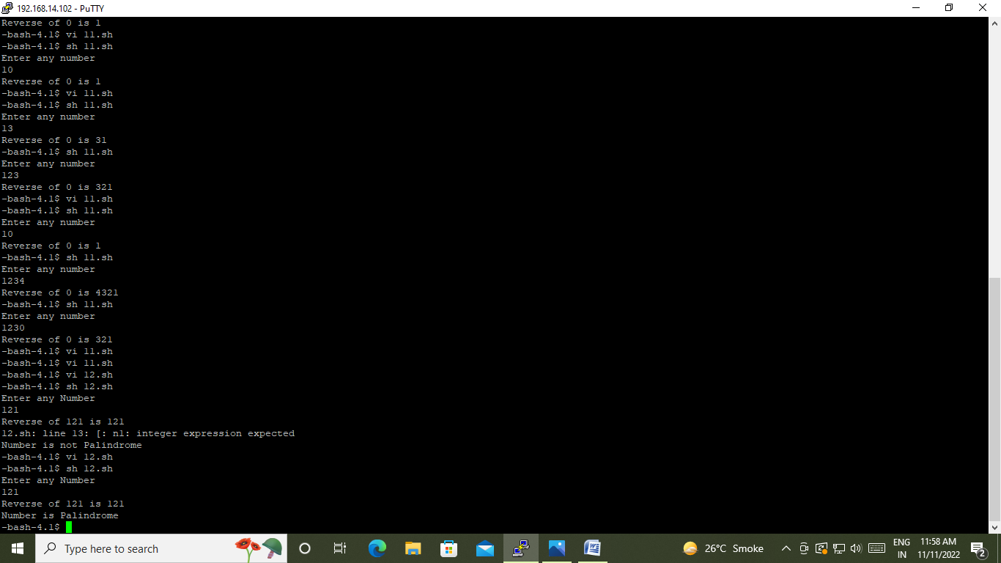

**OUES 4: PROGRAM TO PRINT MULTIPLICATION TABLE FROM NUMBER 1 TO 10**

**#!/bin/sh**

**i=1**

**while [ $i -le 10 ]**

**do**

**j=1**

**while [ $j -le 10 ]**

**do**

**p=`echo "$i*$j"|bc`**

**echo -n "$p "**

**j=`echo "$j+1"|bc`**

**done**

**echo " "**

**i=`echo "$i+1"|bc`**

**done**

**OUTPUT:**

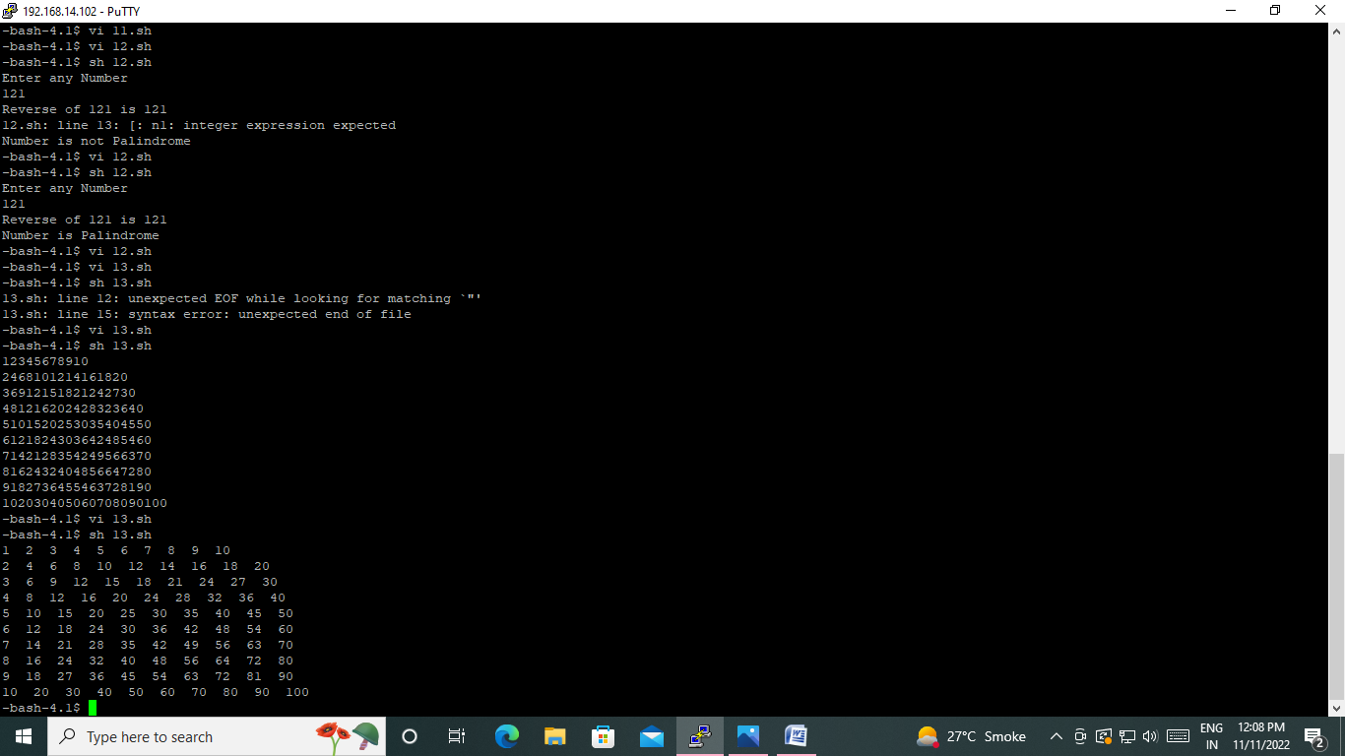

**OUES 5: PROGRAM TO PRINT STAR PATTERN**

**\***

**\*\***

**\*\*\*\***